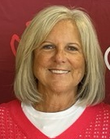
Amy Hazlewood
Dental hygienist
Co-founder
Volunteer Board President

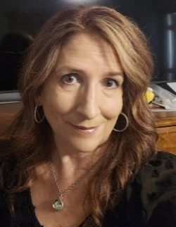
Michelle Peters
Regional Vice President-
Community Health and Well-Being
Saint Joseph Health System,
Loyola Medicine

Volunteer Board Member

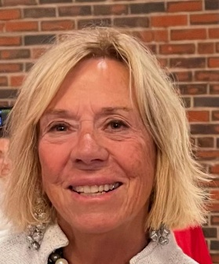
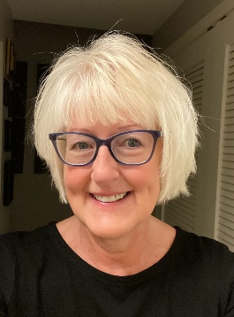
Gwen Foose
Volunteer Board Member
Treasurer
Grant Support

Nanci Yokom
Dental hygienist
Volunteer Board
Vice-President
Former Treasurer
Grant support

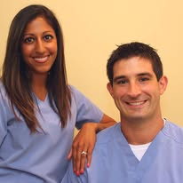
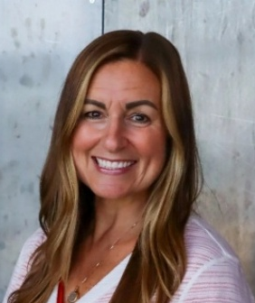
Sheena Zent, DDS
Steven Zent, DDS
Dentists
Volunteer Board Members
Major donors of dental services
Tressa Decker
Educator, School Principal
Grant Support
Denture Coordinator 2025

Volunteer Board Member
starting 2026

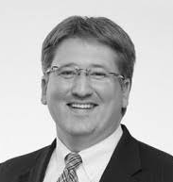
Marcel Lebbin
Attorney
Volunteer Board Member
Legal Advisor
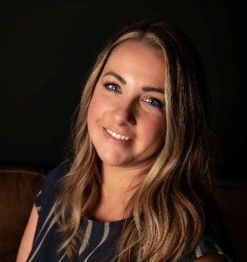
Jessica Casper
Dental Hygienist
Program Coordinator

Salaried employee

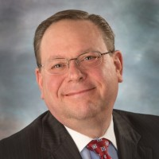
Ed Bassler
Executive Director-
United Health Services
Volunteer Board Member
starting 2026

Former Board Members

Rick Sheffer – Business & Marketing, Board Member
Keith Sherry, MD – Volunteer Board Member
Jan VandePutte – Dental Assistant, Volunteer Board Secretary
Tammy Davis- Dental Hygienist, Co-Founder

